Template for Evidence(s)
UI GreenMetric Questionnaire

University : ...
Country : ...
Web Address : …

[5] Transportation (TR)
SAMPLE
[5.5] Shuttle Services (TR.2)

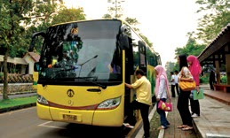 | 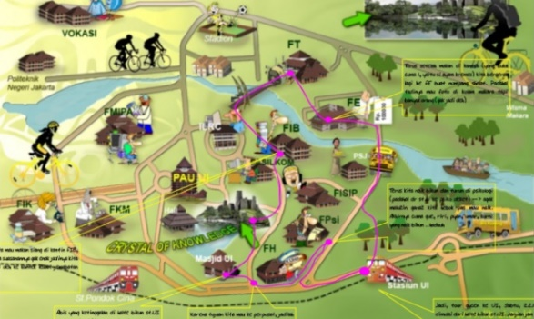
Example of Shuttle Services (Universitas Indonesia, Indonesia)
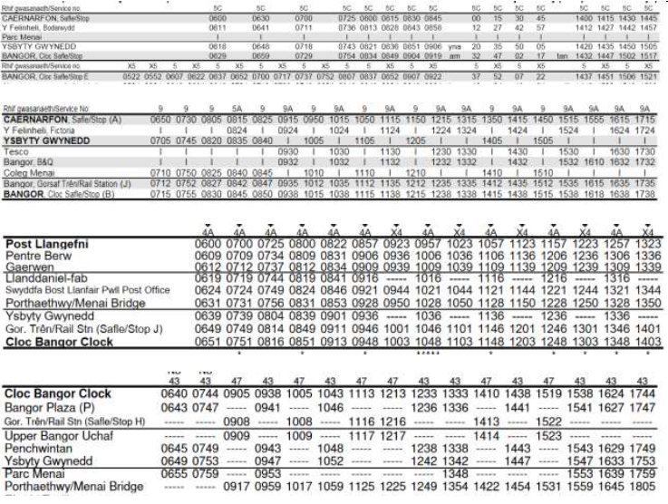
Example of Shuttle Services – Bus Timetable (Bangor University, UK)
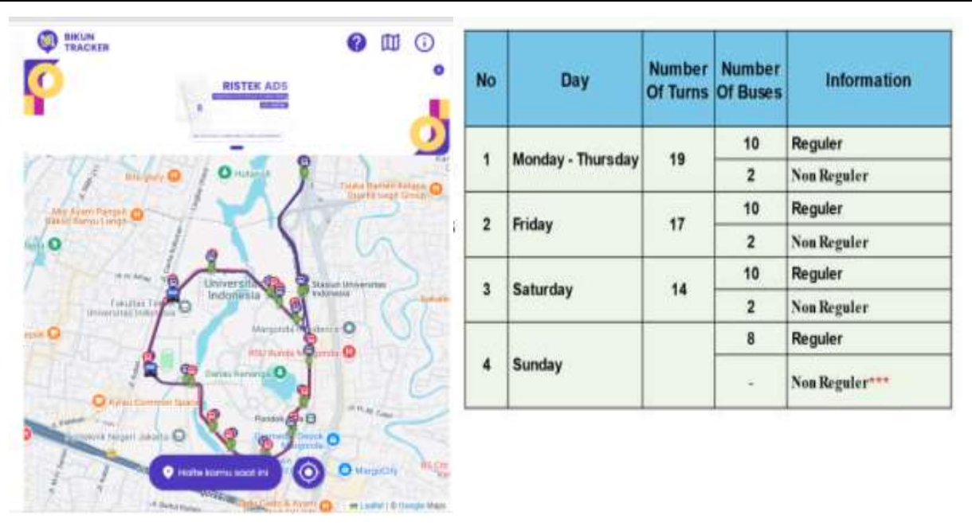

Description:
(Please describe the shuttle services on your campus. The following is an example of the description. You can describe more related items if needed.)

The evidence provided may also include maps showing the location, area size, route, or distribution of facilities relevant to the indicators

University sites in and around Bangor and Menai Bridge are very well served by local buses run by the County Councils so there is very little demand for shuttle buses. To view all the timetables

Additional evidence link (i.e., for videos, more images, or other files that are not included in this file):
https://www.gwynedd.llyw.cymru/en/Residents/Parking-roads-and-travel/Bus-timetables/Bustimetables.
aspx
http://www.anglesey.gov.uk/transport-and-roads/public-transport/bus-or-coach/local-bus-timetables/
The University also actively supports Traveline Cymru’s journey planner scheme, myunijourney
http://planet.cymru/en/feeling-lost-in-bangor/

